PRACTICAL INFORMATION
FOR YOUR SUMMER SCHOOL 2019
The bare necessities
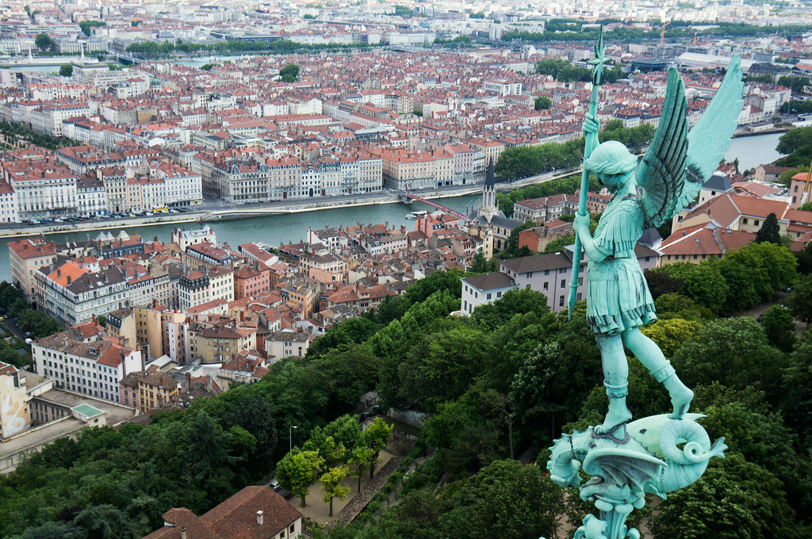
Photo by Nathan FOX, American student, Summer School 2014

Welcome to Lyon and
Thank you for joining our Summer School!

IPL International Summer School #IPLSummerSchool

TABLE OF CONTENTS

I – CONTACTS 2
II – STUDENTS RESIDENCE & MEALS 4
III - ACADEMIC INFORMATION 5
▪ PROGRAM AND CLASSROOMS 5
▪ EVALUATION 5
▪ COMPUTER RESOURCES 5
IV - PUBLIC TRANSPORTATION 6
V – LIFE IN LYON 6
VI - PICK UP ARRANGEMENTS 8
VII - MISCELLANEOUS 9

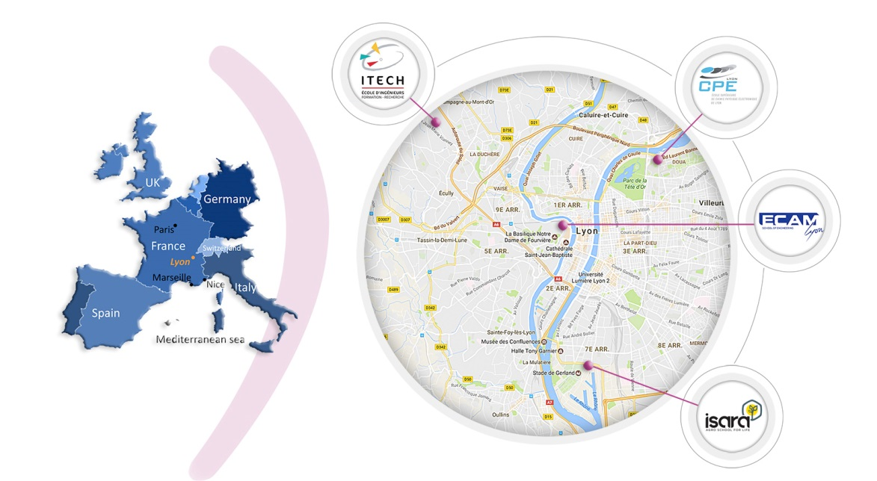
I – CONTACTS

- CONTACTS AT ISARA-Lyon

Bérénice FUERTES, International Relations Coordinator
Emergency only: + 33 (0) 6 45 68 36 13 – office B310

Cathy MOGHAIT, Program coordinator and contact person
Emergency only: + 33 (0) 6 24 90 84 96 – office B310

- CONTACT PERSON AT ECAM-Lyon
Lisa VERGARA, International Relations Coordinator
Tel: +33 (0) 4 72 77 06 71.
Emergency only: + 33 (0) 6 85 82 13 85

- CONTACT PERSON AT CPE-Lyon
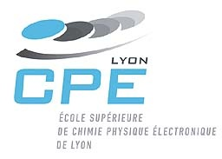
Maria-Angelina BEAUCOURT/Ambre ETIENNE, International Relations Coordinator
Tel: +33 (0) 4 72 43 29 98

- CONTACT PERSON AT ITECH-Lyon

Benjamin JONES, International Relations Department
Tel: + 33 (0) 4 72 18 01 72
Emergency only: + 33 (0)6 67 60 63 19

II – STUDENTS RESIDENCE & MEALS

The address of the residence is:
Please note: upon arrival, you will be asked to fill out an information form, and give a copy of your passport (pages with your ID).
Résidence Jacques Cavalier
8 Rue Jeanne Koehler
69003 Lyon

- YOUR ROOM:
It is a furnished single room (around 10m²) with a small shower/toilet bathroom. There is also a small fridge in the room. Bed linen, duvet and pillow are provided.
/ ! \ Bath towels are not provided. Do not forget to bring them!

Facilities: There are laundry rooms (3.30€). The cleaning is not done in your bedroom, but a broom is at your disposal on each floor. You will need to buy your own toilet paper. Also, rooms can get very hot in the summer, and there is no air conditioner or fan. You can bring a small fan with you or buy one in France for around 20€.

It is possible to extend your stay for a few nights after July 18th, but you will need to inform the residence at least a week prior July 18th.
Each extra night will be charged 23€.

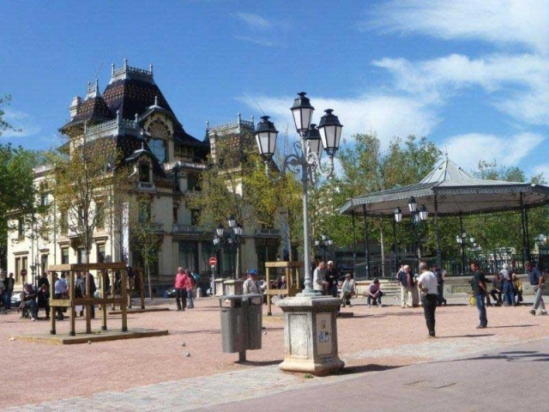
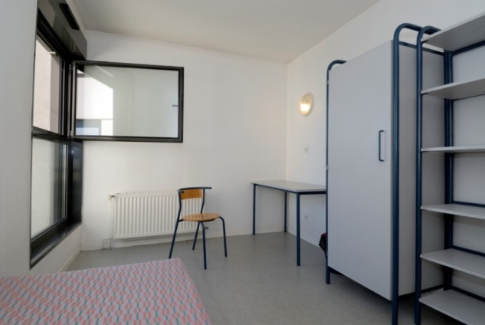

Example of a room in a CROUS residence Monplaisir Lumière district

- MEALS:
In the Residence: there is a common kitchen on each floor. We will provide you with kitchenware and dishes in exchange for a 5€ deposit to be paid upon your arrival (you will get it back at the end of your stay in exchange for the kitchenware provided). Or, if you prefer, you can bring your own. Near the Residence, in Monplaisir district, there are several places to eat and drink.
Near ISARA: there are two cafeterias (“restaurant universitaire” or “Resto’U”).

III - ACADEMIC INFORMATION

PROGRAM AND CLASSROOMS
All French language classes will be held at ISARA. You will be divided into groups according to your level; the aim is not to evaluate your level at the end but rather to assess the progress in your French between the beginning of the summer school and the end.
The scientific courses will be held in each school: CPE Lyon, ECAM, ITECH and ISARA according to your field of study. All scientific courses are in English. Remember that all Summer School lessons and outings are mandatory, and should be attended on schedule.

All the information about programs and visits will be posted daily on the Summer School Facebook group and on the information board at the 2nd floor of the ISARA building (next to the classrooms for French). Make sure you look at it to keep up-to-date!

EVALUATION
At the end of your program you will be given a transcript with your results for the final French test and for your work on a scientific project (work to be done all along the program with a final presentation). In case the certificate is not ready at the end of the Summer School, it will be sent by mail to your permanent address (+ a copy by email) and to your university.

Grades are awarded with ECTS (European Credit Transfer System) credits. Grades being: A, B, C, D, E, FX, F (E = minimum pass grade). The French module will give you 3 ECTS credits, and the science project 3 ECTS credits (except for ISARA and ECAM 6 ECTS).

COMPUTER RESOURCES
A computer account will be created in each school for the students of the Summer School. Your account and password will be given to you. There will be a session on how to use computer resources at the beginning of the program. You will then be able to access your school’s Wi-Fi network at any time.

Wi-Fi is provided by the Residence as well as computers for those who cannot bring their own laptops. However, it is easier to have your own laptop to prepare the scientific courses project.

IV - PUBLIC TRANSPORTATION

During your stay, you will use the public transportation network (TCL – Transports en Commun Lyonnais) every day with a transport card. Transportation for the month of June and July is included in the Summer School fees; Cathy will provide you with your transportation card upon arrival.

- SUBWAY, TRAM & BUS
There are 4 lines from A to D (from one side of a line to the other it takes about 30 min), 5 tramway lines and 2 funicular lines. A complete map will be provided to you upon arrival, but you can also take a look at it on http://plan-interactif.tcl.fr/.

If you know the names of your arrival and departure stops, you may use the TCL website (http://www.tcl.fr/en). It is very easy to use and provides important information on schedules for instance.

IPL Summer School 2016 – travels…

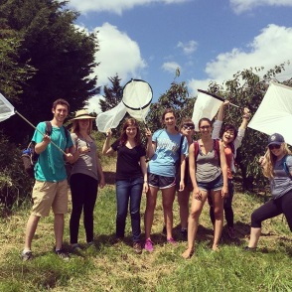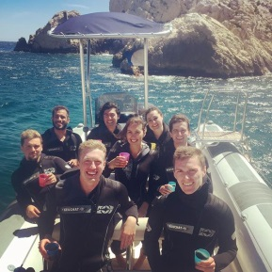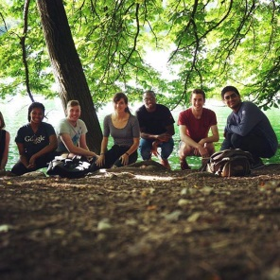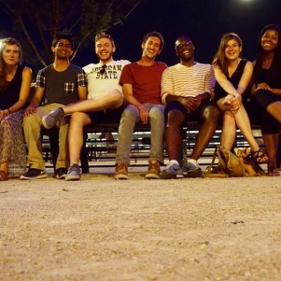
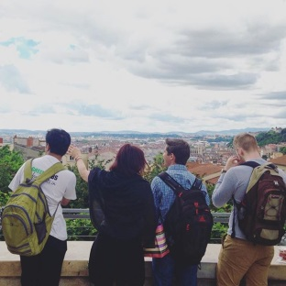

V – LIFE IN LYON

- CELL PHONE AND SIM CARDS
It is highly recommended that you bring your phone, previously unlocked, so that you’ll be able to use a French SIM card. It will then be easier for us to reach you if necessary. A SIM card can roughly cost 10€, and it is a “pay-as-you-go” or pre-paid system. Don’t hesitate to ask Cathy for more information if you are interested in buying a French SIM card.

- HEALTH INSURANCE
Before your departure, do not forget to buy a medical insurance cover for the entire length of your stay in France and send us a copy by e-mail prior to your arrival. This insurance has to cover any accident, illness, hospitalization, repatriation and civil/third party liability.

- CREDIT CARD
An international credit/debit card will be preferred, if possible with a chip (American express is rarely accepted in France for example). It is important as you will not be able to charge your student card for meals or your transport card without it. However, if your card does not have a chip, make sure you can withdraw money from a cash machine (we will give you details on cash points nearby the residence and schools). Please note that French people pay almost everything by card (even bread!!).

- AROUND TOWN
Picture taken from Lyon city Website
Lyon is a very dynamic city, especially in the summer! There are many things to do and see. We’ll give you the programs of different events when you’ll arrive. Meanwhile, you can take a look at these:
- Lyon’s main website (French)
- Lyon’s guide for restaurants, events, etc. : Petit Paumé & Lyon City Crunch
(Both in French only)
- Only Lyon, Lyon’s most famous slogan (http://www.onlylyon.com/en/)

The Information Point (Office de Tourisme) is on Bellecour square (The central point of the city centre)
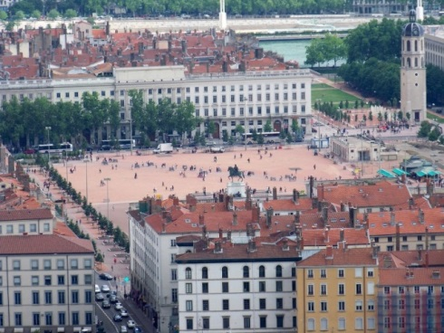

VI - PICK UP ARRANGEMENTS

Upon your arrival, one person from one of the 4 engineering schools participating in the Summer School will be waiting for you at the airport or at the train station Part-Dieu with a sign (possible at train station Perrache too). For students arriving at the train station Part-Dieu, the meeting point will be in front of the Starbucks coffee shop inside the station; close to the exit “Porte Alpes” (the subway is on the opposite side).

In a separate email, we will send you a document with the pick-up arrangements by arrival order. Please check your arrival details and let us know by return if there is any change.

“Rhônexpress”: Railway to/from “Lyon Saint Exupéry” international airport
“Gare Part-Dieu”: Lyon’s main train station, along with “Gare de Lyon-Perrache”

Even if we are late at the arrival gate or at the train station, please wait for us! There will be many arrivals at the same time, which may cause some slight delays on our part. If you arrive prior to the pick-up date we’ve established and thus have to get to your residence on your own, or if your flight is delayed, please keep us informed on our mobile phones. If we are not able then to pick you up at the airport/train station because of a delayed plane/train, please note that you can reach the students residence Jacques Cavalier as follows:

From Lyon Saint Exupery international airport:

Take the Rhone-Express
Departure: every 15 minutes – Duration: 30 minutes
Cost: 16.10€ per person (14.90€ when booked on the Internet) or 13.40€ for people under 25 years old
Website: https://www.rhonexpress.fr/

Once at the train station Part-Dieu, you need to cross through the station to the “Porte Rhône” or subway exit (indicated with a capital for metro). Take the subway line B (blue line) in the direction of “Gare d’Oullins”. Then, you have to stop at “Saxe-Gambetta” where you will take the subway line D (green) towards “Gare de Venissieux” and stop at “Monplaisir lumière”.
Once you get out of the subway/subway, make sure to take the exit on your left. Leave the subway station and on the same side, walk along the avenue Albert Thomas for about 3 minutes. The first on your right is Dr Rebatel Street and the second one is Jeanne Koehler Street where the residence is.

You can also take a taxi directly from the airport to the residence hall (35 minutes, but the price will be rather high: around 60€) or directly from the train station Part-Dieu (about 15 min / 15-20€).
TAXI LYONNAIS
+33 (0) 4 78 26 81 81

/!\ Be careful not to take a train to “Gare de Lyon”: it is a train station in Paris!

VII - MISCELLANEOUS

Don’t forget to like our Facebook page “IPL International Summer School” and join our Facebook group for the 2019 cohort!!! Cathy will be posting information about the activities, events, etc. during your stay.

Also refer to IPL’s advice here.

Do not forget to bring:

- Note-paper and pens for classes (or buy them once arrived)
- Bath towels
- Comfortable (closed) shoes for the cultural outings (visit of Lyon, visit of the CERN, field trip visit…)
- Suitable clothes for June in France. You can have very warm days (35°C) but also some chilly days (14-18°C). Bring long-sleeved sweaters and something to protect you from the rain (raincoat + umbrella). Please also note that facilities are rarely air-conditioned, and there are no mosquito screens at the windows.
- Most of the shops are closed on Sundays in France. However, some supermarkets are open until midday and most of the restaurants in the city center are open.
- Voltage is 220 V 50 Hz. Electrical outlets are European type.

We wish you a very pleasant stay in Lyon!

